
​DATA STRUCTURES AND ALGORITHMS
x23160306


Contents
Introduction……………………………………………………………………………………………. 2
Objectives………………………………………………………………………………………………. 2
Description……………………………………………………………………………………………… 2
App Features……………………………………………………………………………………………. 3
Class Diagram………………………………………………………………………………………….. 4

​​

Urban Plant and Wildlife Tracker Proposal
- Introduction
I realized that there are not many data about plants and animals living in urban spaces. My application called Urban Plant and Wildlife Tracker solves this issue by giving citizens the opportunity to help in monitoring plants and wildlife in their city. This can help create and record valuable information. By keeping a record of plants and animals it can help citizens become more aware environment changes in their area. My Plant and Wildlife tracking app can also help raise awareness of biodiversity in urban areas and help citizens become more involved in the nature in the areas.
Plant and Wildlife Tracking App will allow users observe their environment for plants and animals and record any observations. The user will be able to add a new observation, view previous observations, update current observations and delete observations.
Objectives
My objectives for the Plant and Wildlife Tracking App are to create an application using Java. An application that will allow users to record and manage their observations. In terms of object-oriented programming I will apply concepts like inheritance, Abstract Data Types (ADTs), polymorphism, interfaces. I plan to use swing to create a graphical user interface. I will apply CRUD operations (create, read, update and delete) on data stored on the app.

Description
When a user observes a plant or wildlife in urban green spaces like parks or streets, the user will enter observation details through a GUI (graphical user interface). They will enter their id, name, their location, date when observation happened, type of observation such as animal or plants. ----(maybe) type of plant or species.
The NAME OF APP will create an object containing the observations inputted by the user and then it will be stored. The users will be able to view recorded observations, update it details or delete details if not correct or relevant.

App Features
Add observations feature:
Users can enter observation details such as, their name, their location, the date, the type of observation, whether it’s a plant or an animal and they can enter the animals species or the plant type.
View observations feature:
All recorded observations will be displayed in a table showing the observation id number, the persons name, the location of the observation, the type of observation and the species of animal or the type of plant observed.

Update observation feature:
The user will be able to update select an observation and make changes to its details.

Delete observation feature:
The user will be able to remove an observation from the record.

Tracking observations feature:
The application will use Stack structure to manage all the recent observations. This feature will allow users to view recently added observations and delete the most recent observation added to the stack.

Class Diagram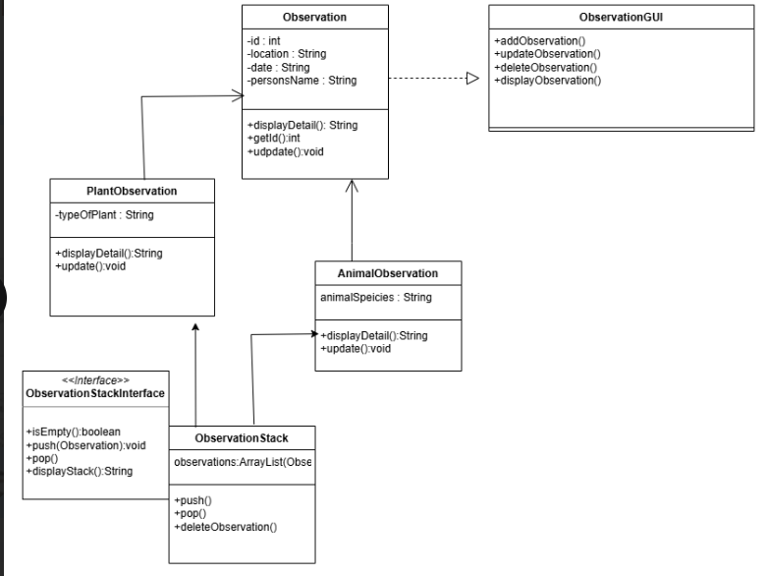

Github
https://github.com/safiatdao/UrbanPlantAndWildlifeTracker.git

